**Original and Current Subcontract Amount is reflecting incorrectly**

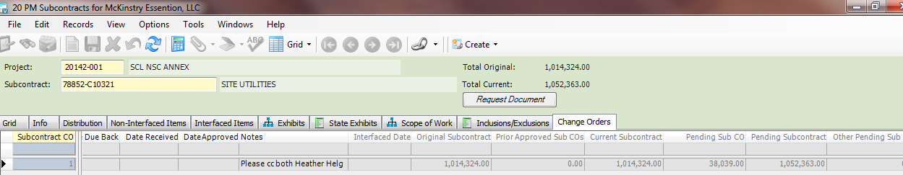

**From:** Latonya Leek   
**Sent:** Thursday, November 20, 2014 2:03 PM  
**To:** Sarah Cantwell; Esther Bandelin; Genevieve Guinn  
**Subject:** Subcontract Change Order Original Amount?

The original subcontract amount is $976,285.00. Her change order amount is $38,039.00. Instead of adding that amount to $976,285.00, it is doubling it, so that the original amount includes that amount and so does the sub amount.

**For example:**

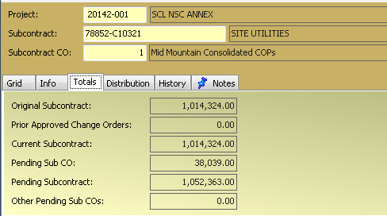

**Should be:**

|  |  |
| --- | --- |
| Original Subcontract | 976,285.00 |
| Prior Approved Change Orders | 0 |
| Current Subcontract | 976,285.00 |
| Pending Sub CO | 38,039.00 |
| Pending Subcontract | 1,014,324 |
| Other Pending Sub COs | 0 |

Have you seen this issue or this a known issue and we need to manually change our template?

Thank you,

Latonya

I went back into a ***previous snapshot*** and confirmed it was converted at $976,275

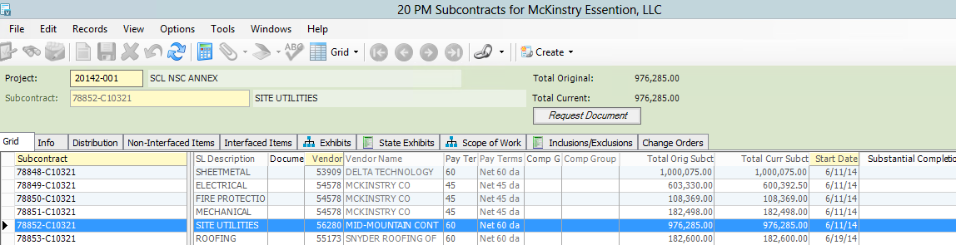

In PM Subcontract Detail (***current system***) and it still shows 976,285

